WEBCAM BASED PAINTING FOR CANVAS APPLICATIONS USING OPENCV AND NUMPY

B. Lohitha Amulya,

B. Pallavi,

K. Vamsi krishna

[19A91A0566@aec.edu.in,](mailto:19A91A0566@aec.edu.in) [19A91A0571@aec.edu.in,](mailto:19A91A0571@aec.edu.in) [19A91A05F5@aec.edu.in](mailto:19A91A05F5@aec.edu.in)

Mr. M. Kalyan Ram MCA, M.Tech (PhD)

*Associate Professor*

Computer Science and Engineering Aditya Engineering College (A)

## Abstract - On displays of electronic devices, people can write, draw, and create various structures, symbols, works of art, and other things. By typing, writing by hand, or even just one tap. Nevertheless, for making it simpler to use and easier to express your emotions by using only your finger movements. We will use Python and OpenCV to develop an air canvas in this project because we are aware that painters frequently use canvas when making their works. A "air canvas" digital drawing uses free-hand sketching with a coloured object. Simply consider what you want to exhibit or communicate, move the object to represent that, and that's all there is to it. In recent years, writing in the air has emerged as one of the most exciting and difficult research topics in the fields of pattern recognition and image processing.. In a variety of situations, it can improve human- machine interaction and considerably progress an automation process. New strategies and techniques that would hasten processing while enhancing recognition in numerous studies. The task of object tracking is regarded as vital in computer vision.

***Due to the development of faster computers, the availability of low-cost, high-quality video photography equipment, and the demands for automated video analysis, object tracking systems are growing in popularity. The three steps of the video analysis method are typically identification of the object, tracking its movement from frame to frame, and behavioural analysis of the object.. Choosing an acceptable object representation, selecting tracking features, detecting objects, and tracking them are the four main factors to take into account.***

## Object tracking algorithms are crucial for many real-world applications, including autonomous surveillance, video indexing, and vehicle navigation. This gap will be filled by the project, It intends to develop a motion-to-text converter that might be utilised as software for wearable smart devices that enable writing in the air. This project serves as a witness to clumsy hand movements. It will follow the path of the coloured object using computer vision.

***Keywords canvas, OpenCV, python, computer vision,***

## mask detection, air button, colored object, character recognition.

1. INTRODUCTION

In the age of the internet, digital art is displacing the traditional form of writing. Digital media are used in artistic expression and communication, which is referred to as digital art. One of the defining features of the digital manifestation is its reliance on contemporary science and technology. Traditional art refers to everything produced before digital art. From the viewpoint of the audience, it can be simply divided into visual art, audio art, audio-visual art, and audio-visual creative art, which includes music, dance, theatre, painting, sculpture, and other types of art. Traditional and digital art are linked and interconnected.

Basic human needs nevertheless act as the main push for societal growth, despite the fact that it is not the outcome of popular demand. The requirement for a clean classroom atmosphere so that students could focus on their studies in peace was the main motivating factor. We're aware of a number of techniques, including touch screens and other electronic devices, What about, however, those educational institutions that cannot afford to purchase such substantial, expensive electronic devices, such as a television or single screen?. Since finger tracking would be feasible, we reasoned, OpenCV would be useful for these computer vision applications.

We all know that painters produce canvas paintings. But what if we could just create art in the air by waving our hands? So, to develop an air canvas for this project, we'll use Python and OpenCV. The same thing happens with art. Because traditional and digital art currently coexist in harmony, it's critical to carefully consider the key distinctions between the two forms of art. Chalk, a board, and a pen are the classic writing implements. The primary goal of digital art is the development of an object detection system that enables digital writing. A variety of writing instruments, such as the keyboard, touch-screen surface, digital pen, stylus, electronic hand gloves, etc., are used in digital art.

However, in system, colour recognition is done using Python programming and a deep learning method called OpenCV, resulting in a smooth interface between humans and machines. The use of Google vision ai API to recognize written text and transform it into computerised text is another development in this project. Additionally, we are creating a text-to-speech component that is integrated with the project so that any text we enter on the canvas will be said aloud.

1. LITERATURE SURVEY

# Babu, S., Pragathi, B.S., Chinthala, U. and Maheshwaram, S., 2020, September. Subject Tracking with Camera Movement Using Single Board Computer. In 2020 IEEE-HYDCON (pp. 1- 6). IEEE.

The system described in the paper can follow topics and pan in real time as a result. By spotting people or other things and panning the camera appropriately to follow and record them, the system imitates a camera operator. This topic tracking camera system can be used in lectures to either assist teachers in recording video without the help of a camera operator or to make the job of a camera operator more manageable. These subject tracking cameras can be used for a number of events, including keynote speeches, guest lectures, and dance performances.

# Chen, M., AlRegib, G. and Juang, B.H., 2015. Air- writing recognition—part i: modeling and recognition of characters, words, and connecting motions. IEEE transactions on human-machine systems, 46(3), pp.403-413.

Writing linguistic symbols or words in a clear space with hand or finger movements is referred to as air-writing. Here, six-degrees-of-freedom hand motion data is used to identify characters or words. Similar to motion gastrulas, isolated air-writing characters can be distinguished, but they are more sophisticated and variable.

# Joolee, J.B., Raza, a., Abdullah, M. And jeon, s., 2020. Tracking of flexible brush tip on real canvas: silhouette-based and deep ensemble network- based approaches. IEEE access, 8,pp .115778-115788.

In this study, we introduced deep ensemble network-based and silhouette-based methods for tracking the position of the brush tip during interactive sketching. The technique based on silhouettes captures.

Using our suggested tracking approach, the tip of the deforming bristles is extracted from the silhouette of the bristles using a pair of well-aligned infrared (ir) cameras, and the 2d position of the tip is then rebuilt. This method still has usability issues and requires a frame and cameras that are carefully placed. We solely take into account a typical size brush in the current job.

# Kaur, h., reddy, b.g.s., sai, g.c. and raj, a.s., 2021. A comprehensive overview of ar /vr by writing in air

Dependency injection was used in this experiment. OpenCV is used to draw with a virtual pen on the camera. Using the contour detection technique centred on the mask of the desired cultured reference marker, any marker may be utilised to draw. The study looked at how frequently people could recognise letters and numbers written outside. During a leap motion, the motion trajectory is recorded and plotted as an uninterrupted stream of points. Major slopes would be determined from the major spots and lines would be combined. Geometry is used to transform significant slopes into directions..

# Shetty, m., daniel, c.a., bhatkar, m.k. and lopes, o.p., 2020, june. Virtual mouse using object tracking. In 2020 5th international conference on communication and electronics systems (icces) (pp. 548-553). Ieee.

This system, which employs hand motions taken from a webcam using a hsv colour detection approach, is a computer vision-based mouse cursor control system. Through the use of coloured caps or tapes that the computer's webcam tracks, this technology enables users to move the system pointer and carry out mouse actions like clicking left, right, or double using a variety of hand motions. The system is implemented using real-time computer vision in Python and the opencv package. The monitor shows the camera output.

# Zhou, l., 2019. Paper dreams: an adaptive drawing canvas supported by machine learning (doctoral dissertation, massachusetts institute of technology).

With a new medium to represent and depict their thoughts, it has the potential to provide a sizable portion of the public, from young people to the elderly, more influence. A web-based canvas called Paper Dreams.

With a multimodal user interface combined with a number of machine learning algorithms for storyboarding and drawing. The system can contextualise what the user is drawing using sketch recognition, style transfer, and natural language processing; it then can colour the sketch appropriately, suggest related objects for the user to draw, and allow the user to draw from a database of related images to add to the canvas.

1. SYSTEM ARCHITECTURE

In the suggested system, a paint window and a mask window are created by the Python IDE, which reads the frame and tracks the item while a person is holding a green object in front of the web camera and the programme is running. A tracking window is integrated with several air ink buttons that allow us to observe the tracking of objects. This is very helpful for instructors to use when instructing children in a classroom setting because it is a creative approach to engage and educate young learners.

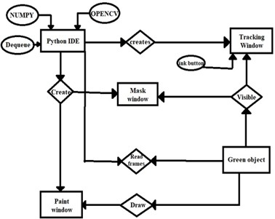

Figure 3. 1

It aids in a better understanding of the linkages in the model, as well as the libraries used and the methodical process through which the model operates.

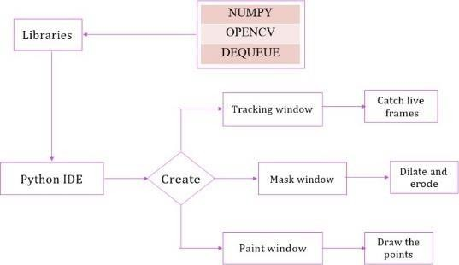

Figure 3. 2

1. STEPS INVOLVED
   1. Reading frames

In the Python IDE, import the required packages, such as opencv and numpy.

constructing the track bars required for marker colour adjustment. Using these track-bars, the upper and lower ranges of the hsv required for a specific colour will be determined. delivering several arrays to accommodate input colour points of different colours.

The points of a specific colour will be kept in these arrays, which will then be utilised to draw on canvas.

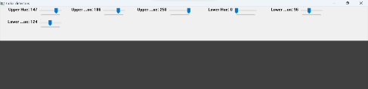

Fig. 4.1 colour detectors

* 1. Creation of a canvas window

Use the np.zeros() function to generate a zero matrix.

To modify the colour of the pencil, place some colour buttons on the window's top. These indexes will be used to identify where the pointers in the colour array are located.

the kernel that will be utilised for dilatation.

the hues that will be used as the drawings' ink. setting up the canvas.

loading the webcam installed into the pc.

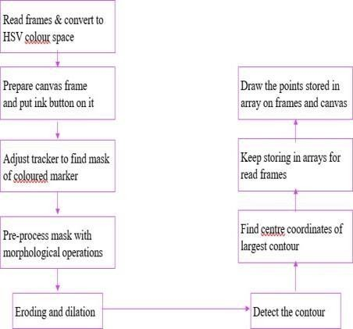

Figure- 4.2

* 1. Green colour detection

Making the pointer's mask to identify it. After locating the pointer, look for its outlines.

If contours have been produced, sort them to identify the largest one.

Obtain the diameter of the circle that contains the identified contour.

Circle-draw the shape in a circle. determining the contour's centre of detection.

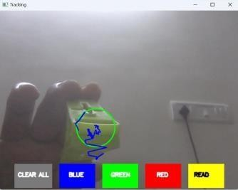

Fig. 4.3 green coloured object detection

* 1. Drawing on canvas

the user's desire to click any of the buttons above the screen is now being ascertained.

Check the colour range in which the circle's centre coordinates are present using the if/else statement.

Choose that colour index to draw with if it is present in that range of colours.

When nothing is discovered, append the subsequent dequeues to prevent confusion. Draw lines on the canvas and frame using all the colours.

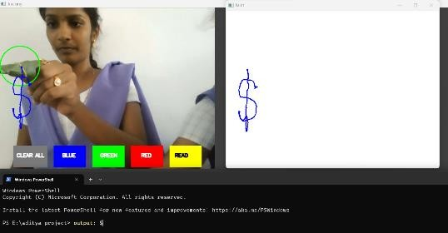

Fig. 4.4 drawing on a canvas

1. DETECTING WRITTEN CHARACTER AND CONVERTING IT INTO COMPUTARIZED

TEXTFORMAT LIVELY USING GOOGLE VISION AI API.

The optical character recognition (OCR) and tagging of particular material, as well as image labelling, face and landmark identification, are all easily integrated into apps thanks to the google cloud vision api. Through rest and rpc arthropod genera, the Vision API provides robust pre-trained machine learning models. Give pictures labels to swiftly sort them into a large number of specified categories. Explore written and written material, find things, and add useful details to your photographic portfolio.

Output- 5.1

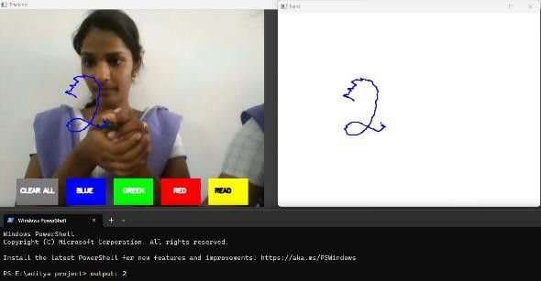

Output-5.2

Output-5.3

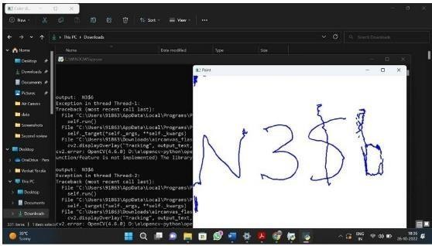

1. CONCLUSION

The system may measure the effectiveness of traditional writing methods. It removes the requirement that you have a phone in your pocket when taking notes and provides a practical way to do the same while you're on the go. Additionally, it will be quite beneficial for individuals who are particularly abled in terms of communication facilitation. Even elderly folks or those who have trouble using keyboards will be able to use the system easily. The system's adaptability will soon be increased by the addition of the ability to control IoT devices. In addition, pulling air is possible. Users of smart wearables will be able to interact with the digital world more successfully because to the technology. Augmented reality can bring text to life.

The system has a number of problems, but these can be fixed later. Using a handwriting recognizer rather than a character recognizer while writing word by word enables faster writing. Second, instead of employing the number of fingertips, hand motions with a pause can be employed to control the real-time system. Thirdly, our system occasionally detects fingertips that are far away and modifies their status. Air-writing systems must only obey the control gestures of their master and must not be duped by nearby individuals.

REFERNCES

1. Y. Huang, x. Liu, x. Zhang, and l. Jin, "a pointing gesture based egocentric interaction system:dataset, approach, and application," 2016 ieee conference on computer vision and pattern recognition workshops (cvprw), las vegas, nv, pp. 370-377, 2016.
2. 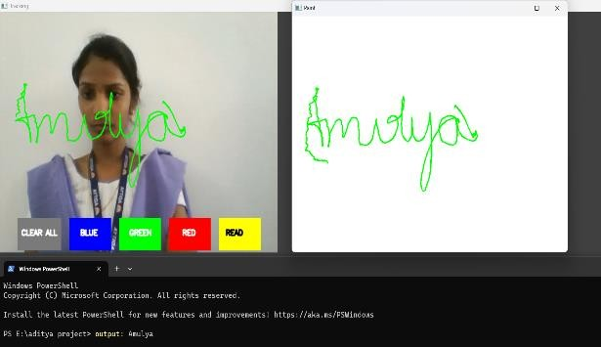P. Ramasamy, g. Prabhu, and r. Srinivasan, "an economical air writing system is converting fingermovements to text using a web camera," 2016international conference on recent trends in information technology (icrtit), chennai, pp. 1-6, 2016.
3. Saira beg, m. Fahad khan and faisal baig, "text writing in air," journal of information displayvolume 14, issue 4, 2013.
4. Alper yilmaz, omar javed, mubarak shah, "object tracking: a survey", acm computer survey.vol. 38, issue. 4, article 13, pp. 1-45, 2006.
5. Yuan-hsiang chang, chen-ming chang, "automatic hand- pose trajectory Tracking system usingvideo sequences", intech, pp. 132- 152, croatia,2010
6. Erik b. Sudderth, michael i. Mandel, william t. Freeman, alan s. Willsky, "visual hand trackingusing nonparametric belief propagation", mit laboratory for information & decision systems technical report p-2603, presented at ieee cvpr workshop on generative model-based vision,pp.1-9, 2004
7. T. Grossman, r. Balakrishnan, g. Kurtenbach, g. Fitzmaurice, a. Khan, and B. Buxton, "creatingprincipal 3d curves with digital tape drawing," proc. Conf. Human factors computing systems(chi' 02), pp. 121- 128, 2002.
8. T. A. C. Bragatto, g. I. S. Ruas, m. V. Lamar, "real-time video-based finger spelling recognitionsystem using low computational complexity artificial neural networks", ieee its, pp. 393-397,2006.
9. System using posture classifier and jordan recurrent neural network", ieeeworld congress on computational intelligence, brisbane, australia, 2012
10. Ruiduo yang, sudeep sarkar, "coupled grouping and matching for sign and gesture recognition",computer vision and image understanding, elsevier, 2008
11. R. Wang, s. Paris, and j. Popovic, "6d hands: markerless hand-tracking for computer-aided design," inproc. 24th ann. Acm symp. User interface softw.Technol., 2011, pp. 549–558.
12. Maryam khosravi nahouji, "2d finger motion tracking, implementation for android basedsmartphones", master's thesis, chalmers applied information technology,2012, pp 1-48
13. Eshedohn-bar, mohan manubhaitrivedi, "hand gesture recognition in real- time for automotiveinterfaces," ieee transactions on intelligent transportation systems, vol. 15, no. 6, december 2014, pp 2368-2377
14. P. Ramasamy, g. Prabhu, and r. Srinivasan, "an economical air writing system is converting fingermovements to text using a web camera," 2016international conference on recent trends in information technology (icrtit), chennai, 2016, pp. 1-6.zq Gesture recognition,"ieee computer graphics and applications, 2002, pp.64-71.
15. Napa sae-bae, kowsar ahmed, katherine isbister, nasirmemon, "biometric-rich gestures: a novel approach to authentication on multi- touch devices," proc. Sigchi conference on human factors incomputing system,2005, pp.977-986